**DECIMAL TO OCTAL CONVERSION:**

**EXP NO:29**

**AIM:**To write a C program to implement decimal to octal conversion.

**APPARATUS:** DEV C++

**ALGORITHM:**

1)      Store the remainder when the number is divided by 8 in an array.  
2)      Divide the number by 8 now  
3)      Repeat the above two steps until the number is not equal to 0.  
4)      Print the array in reverse order now.

**PROGRAM:**#include<stdio.h>  
int main()  
{  
   long decimal, remainder, quotient,octal=0;  
   int octalnum[100], i = 1, j;  
   printf("Enter the decimal number:");  
   scanf("%ld", &decimal);  
   quotient = decimal;  
   while (quotient != 0)  
    {  
      octalnum[i++] = quotient % 8;  
 quotient = quotient / 8;  
    }  
    for (j = i - 1; j > 0; j--)  
     octal= octal*10 + octalnum[j];  
 printf("Equivalent octal value of decimal no %d is: %d  ",decimal,octalnum);  
    return 0;  
}

**INPUT:**

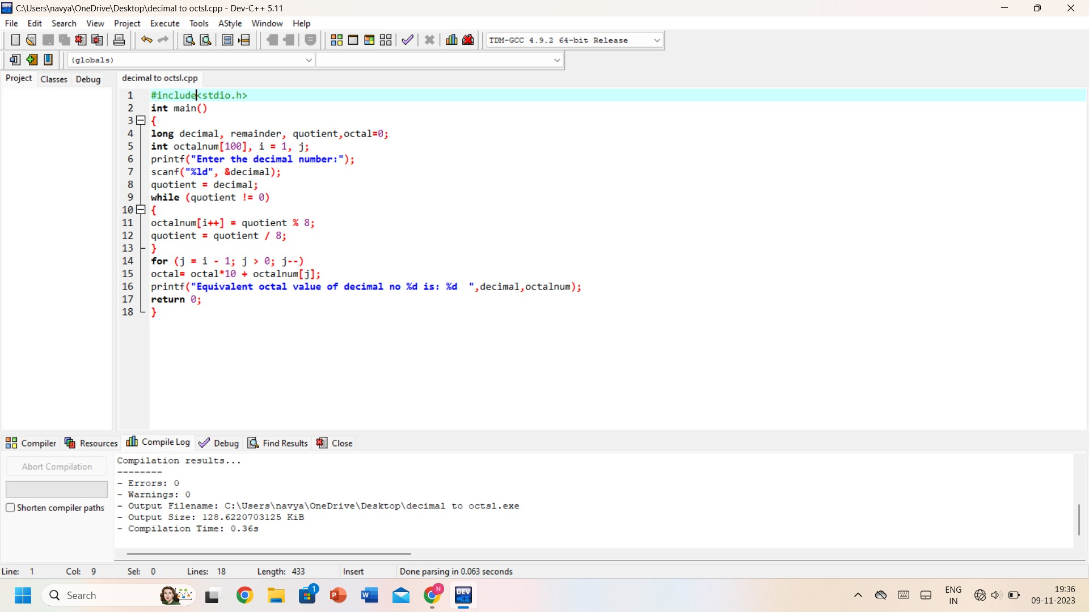

**OUTPUT:**

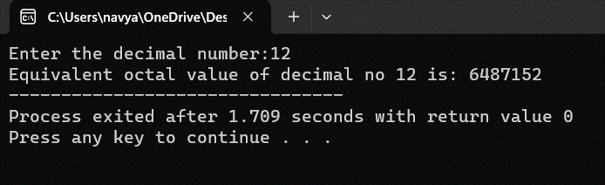

**RESULT:** Thus, the program was executed successfully using DevC++.